**MYSQL ASSIGNMENT_4**

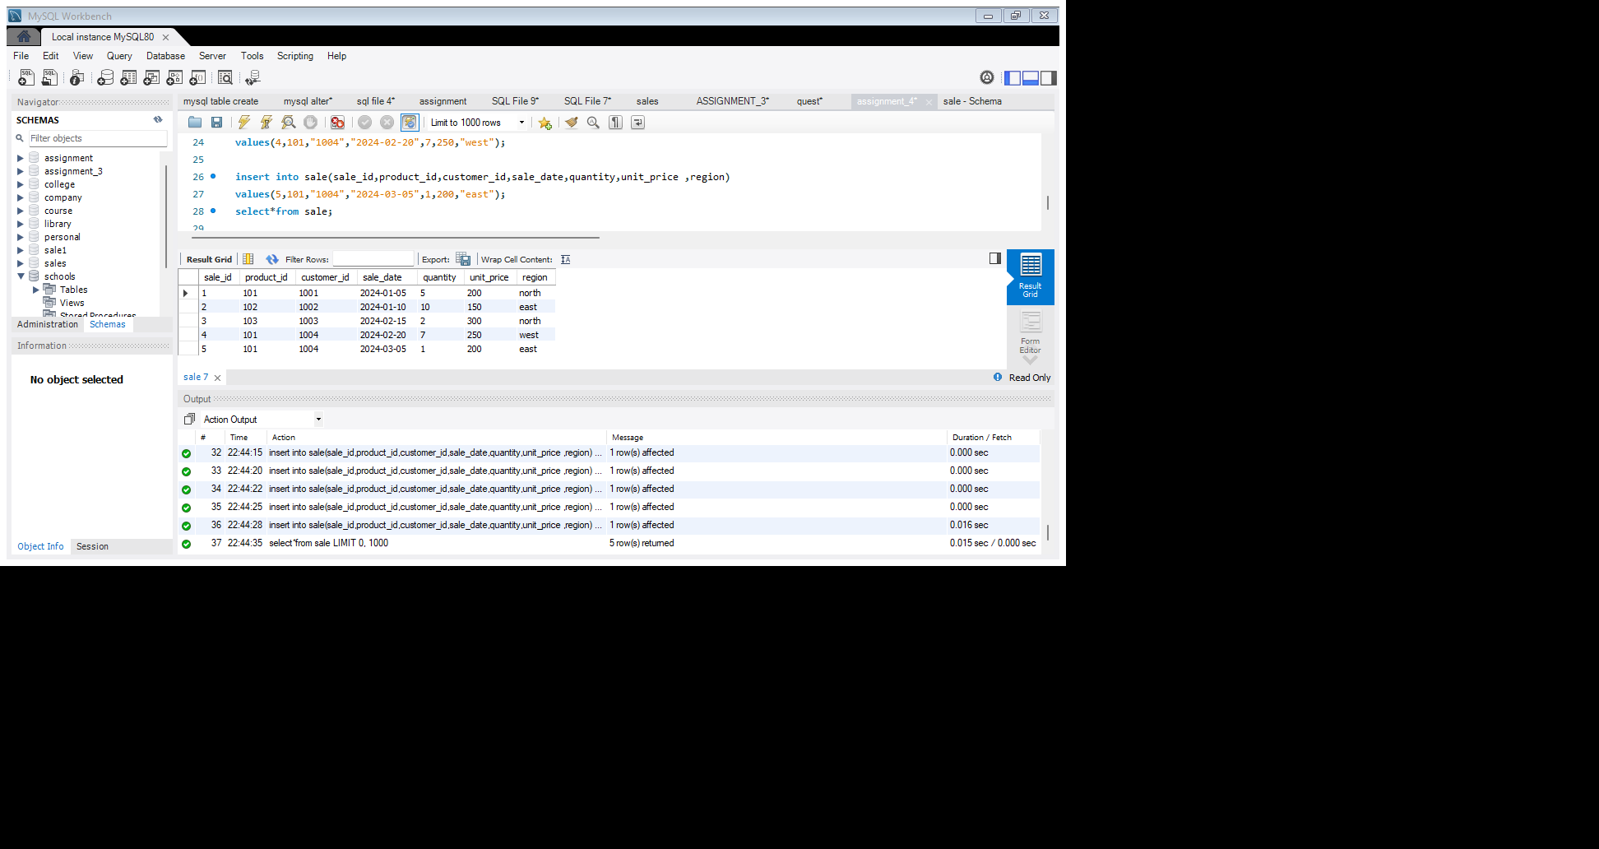1. Write a query to calculate the total sales(Quantity*unitprice) for each product.

**Select product_id,sum(quantity*unit_price)as "total_sale" from sale group by product_id;**

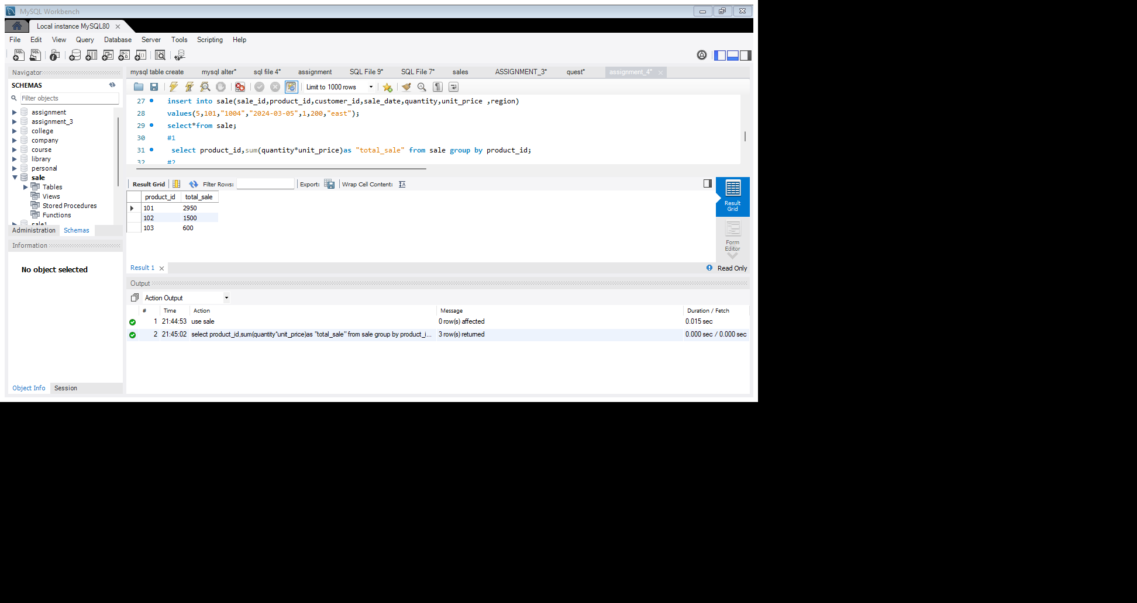

2. Write a query to find the total number of product sold in each region.

**Select region,count(sale_id)as "total no. of product sold"from sale group by region;**

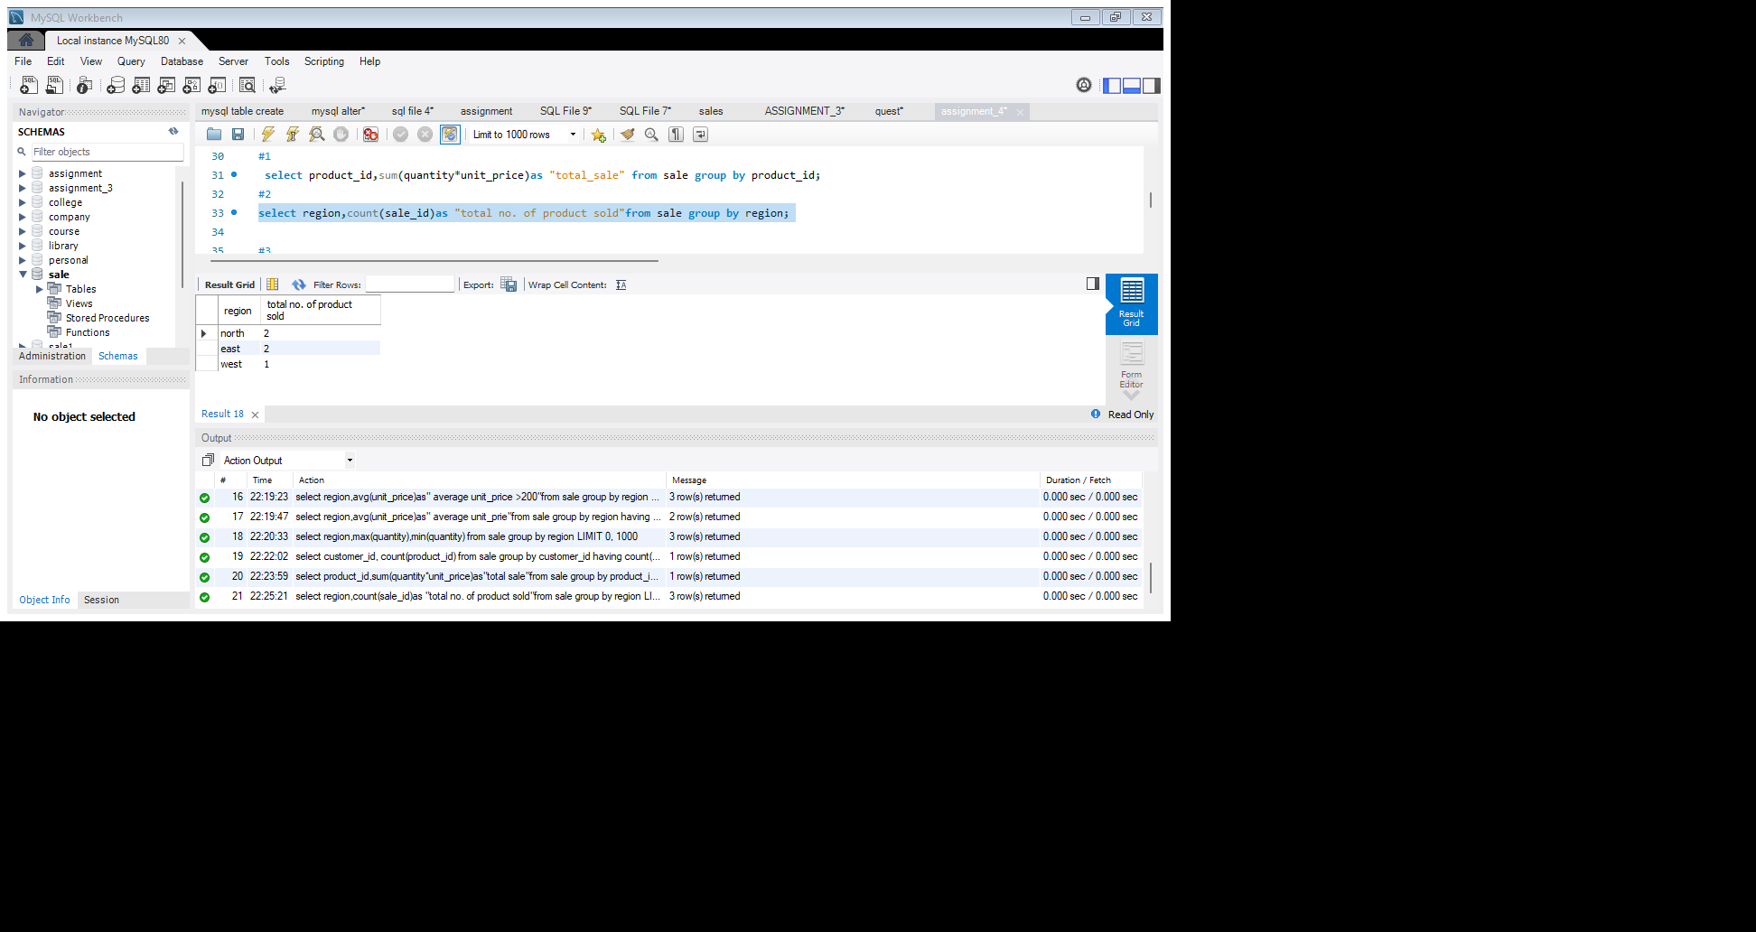

3. Write a query to get the average sales amount per product.

**Select product_id,avg(Quantity*unit_price)as"average sale amount"from sale group by product_id;**

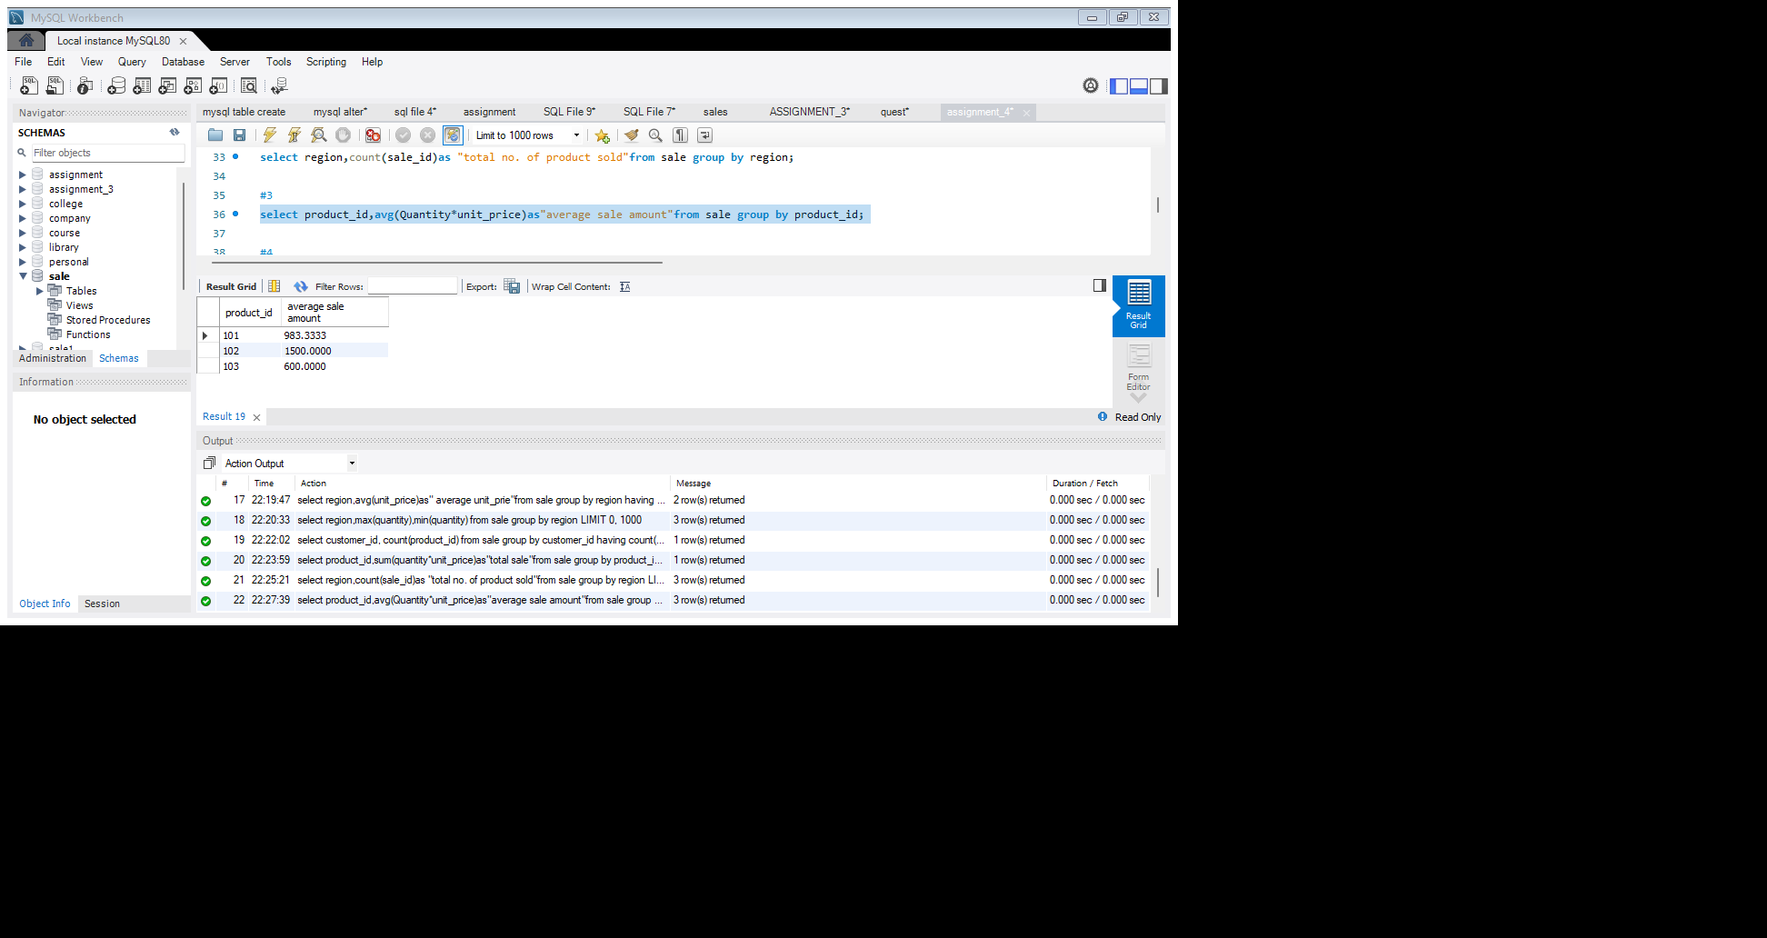

4. Find the regions where total sales are more than 3000.

**Select region,sum(quantity*unit_price)as"total sale"from sale group by region having sum(quantity*unit_price)>3000;**

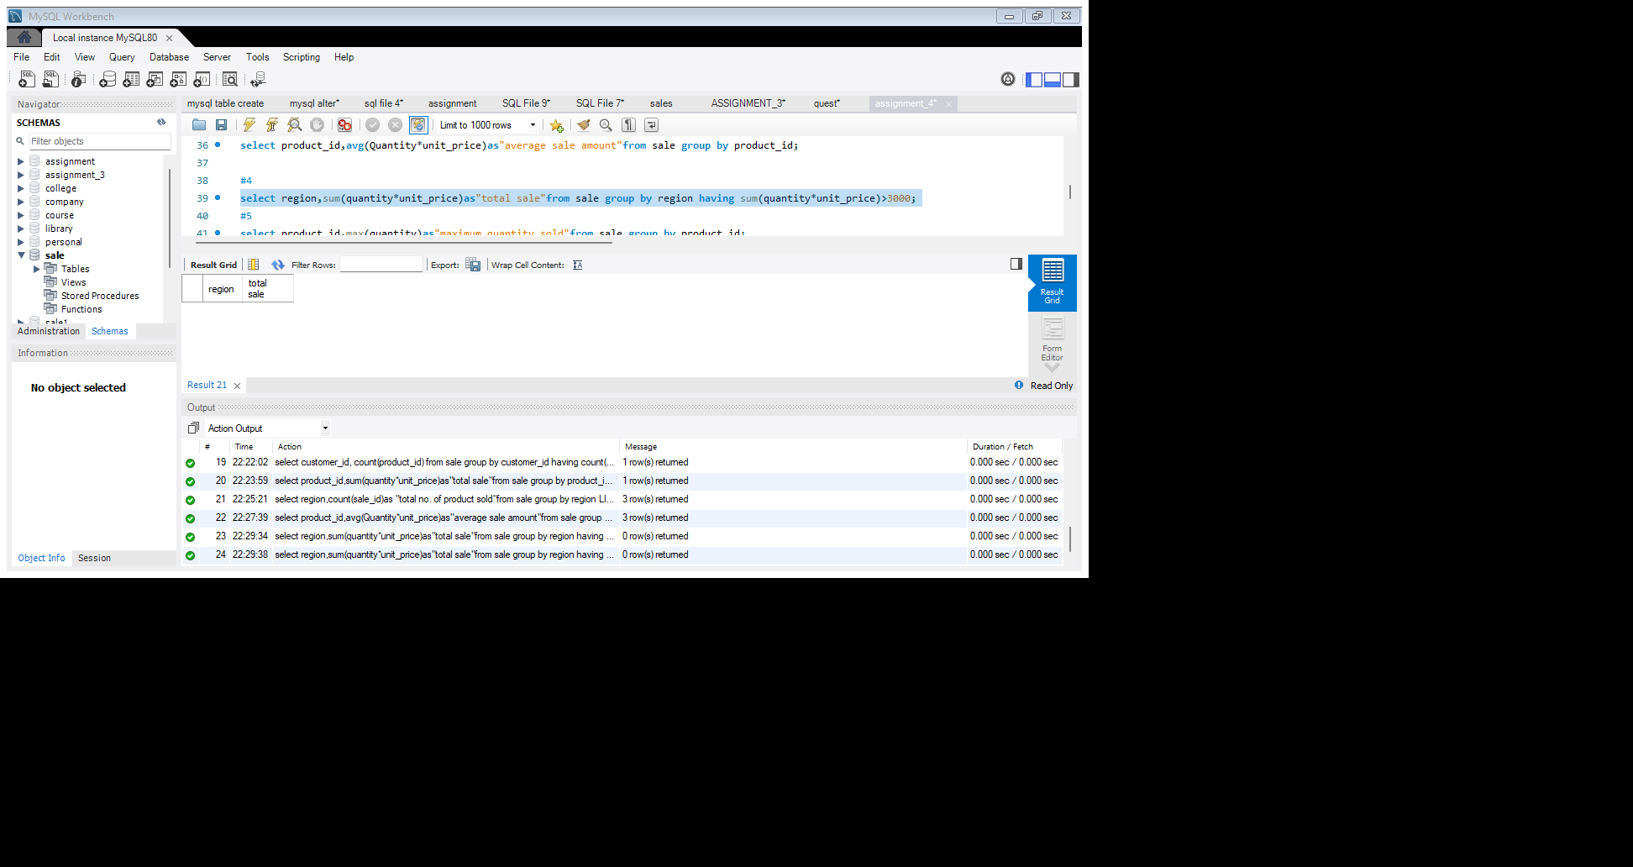

5. Write a query to get the maximum quantity sold for each product.

**Select product_id,max(quantity)as"maximum quantity sold"from sale group by product_id;**

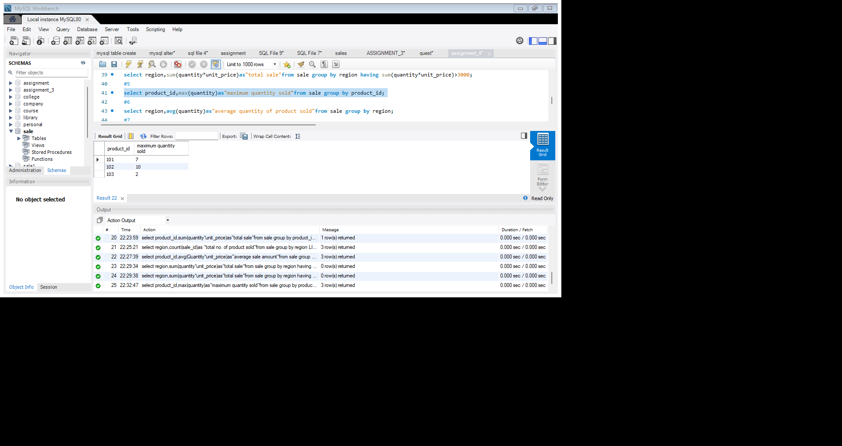

6. Write a query to calculate the average quantity of products sold per region.

**Select region,avg(quantity)as"average quantity of product sold"from sale group by region;**

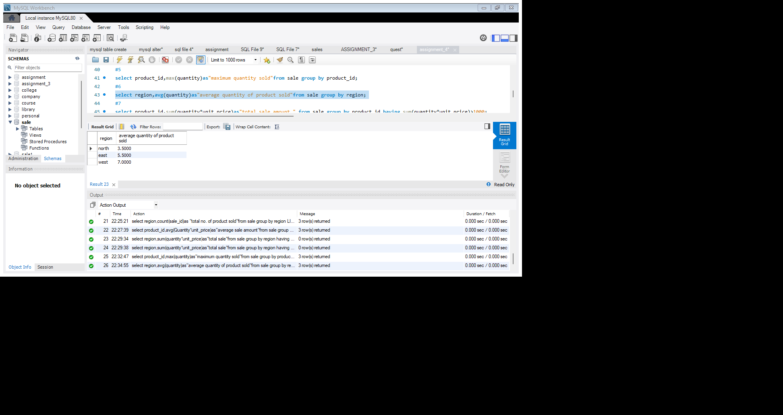

7. Find the product IDs that have generated a total sales amount of more than 1000.

**Select product_id,sum(quantity*unit_price)as"total sale amount " from sale group by product_id having sum(quantity*unit_price)>1000;**

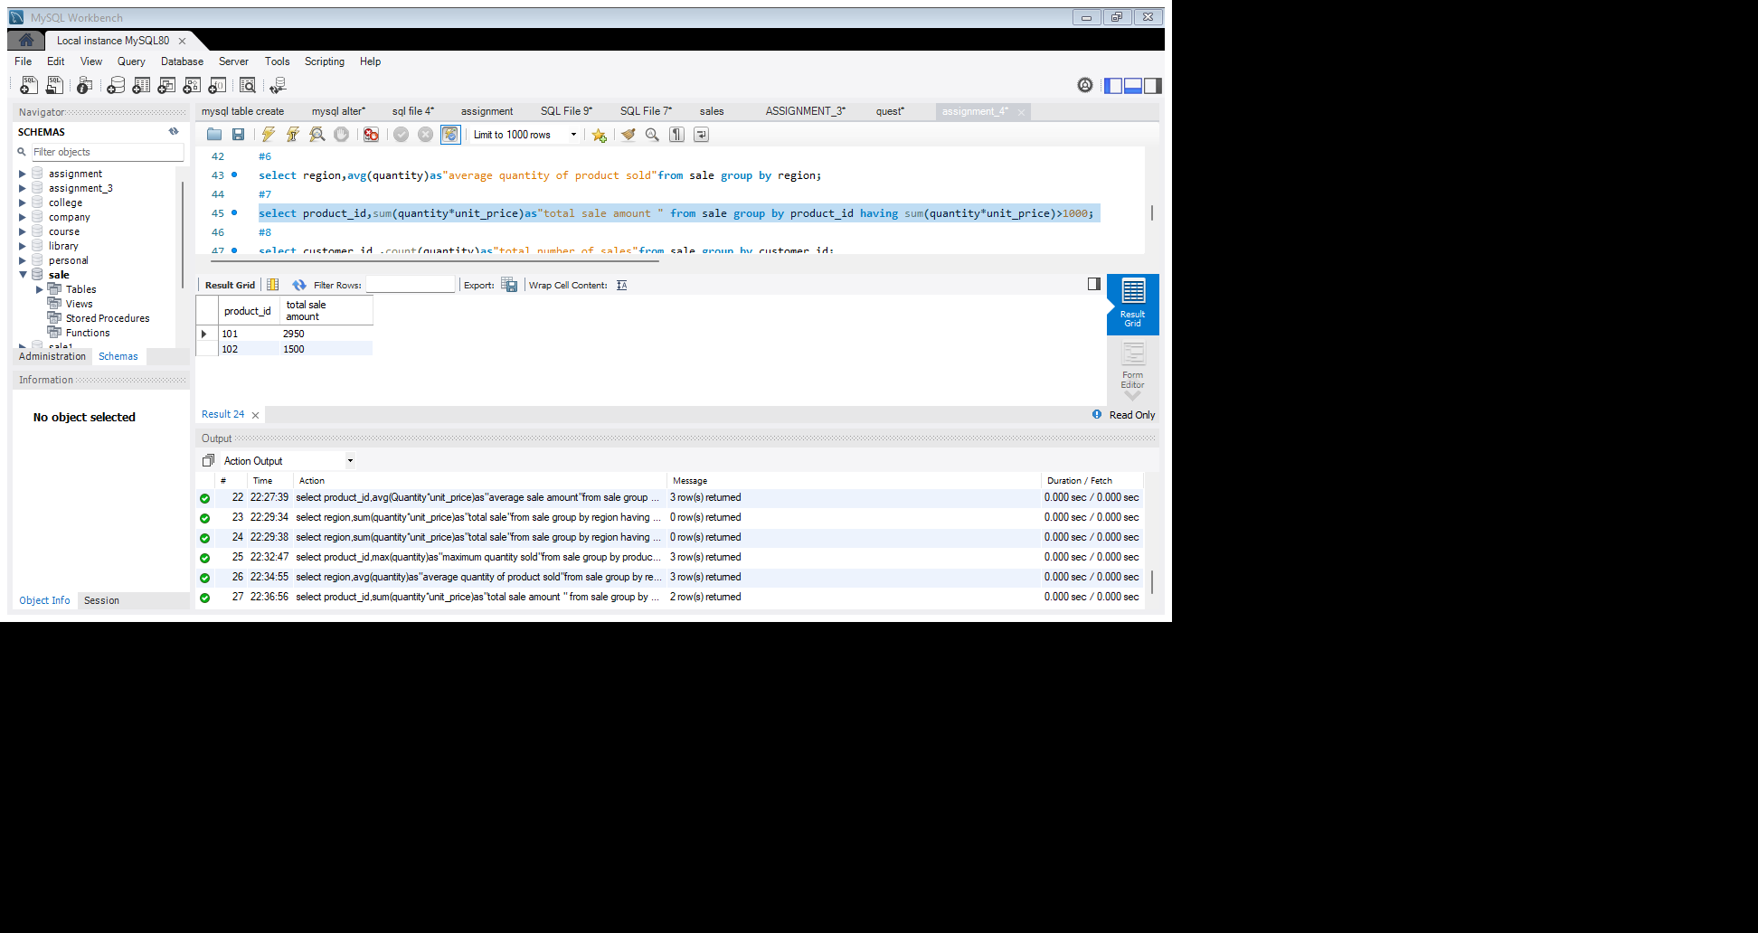

8. Write a query to get the total number of sales (rows) made for each customer.

**Select customer_id ,count(quantity)as"total number of sales"from sale group by customer_id;**

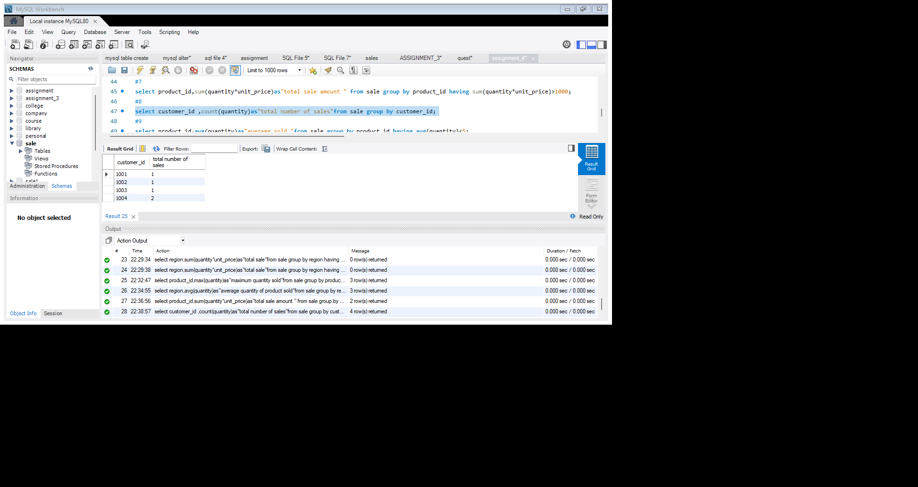

9. Find the products for which the average quantity sold is less than 5.

**Select product_id,avg(quantity)as"average sold "from sale group by product_id having avg(quantity)<5;**

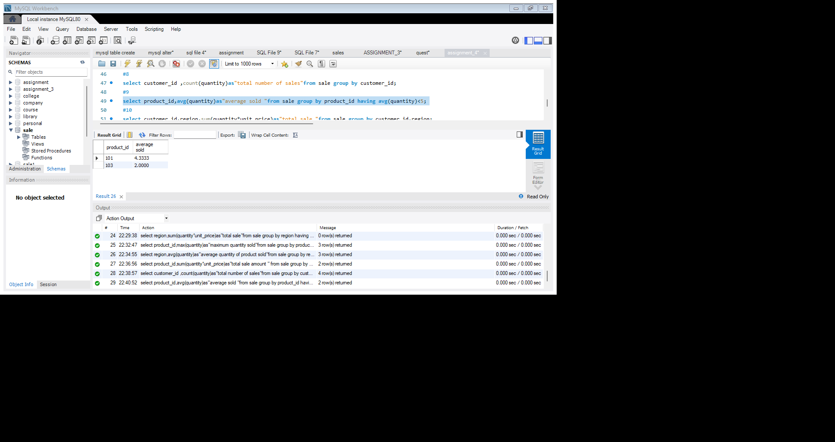

10. Write a query to find the sum of total sales for each customer in each region.

**Select customer_id,region,sum(quantity*unit_price)as"total sale "from sale group by customer_id,region;**

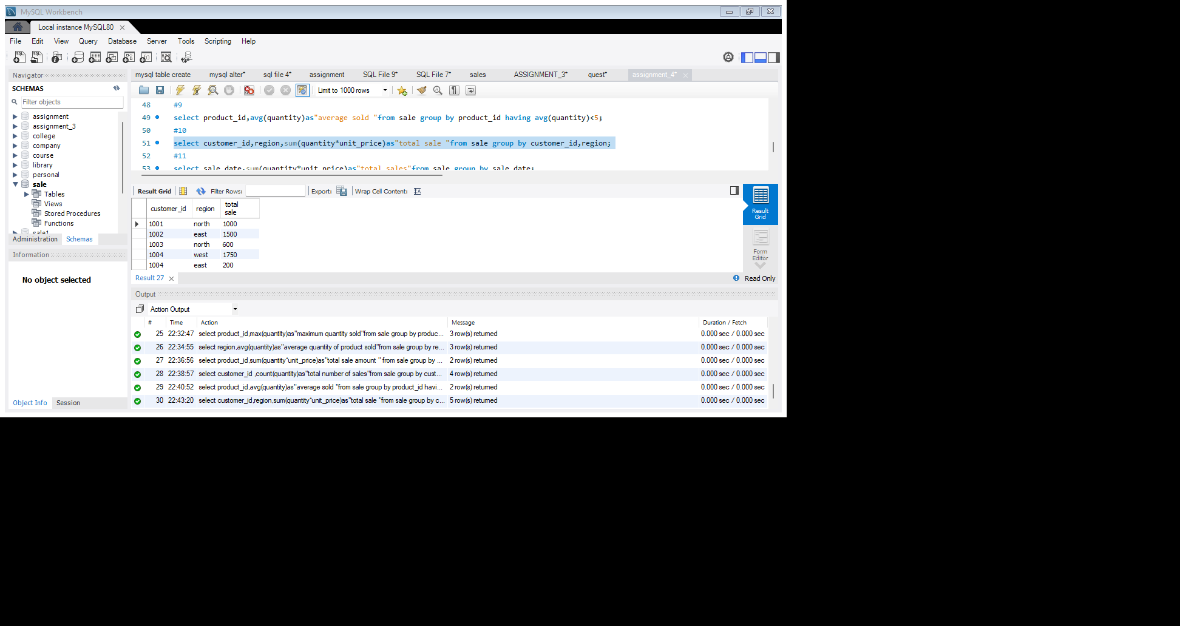

11. Write a query to calculate the total sales for each month.

**Select sale_date,sum(quantity*unit_price)as"total sales" from sale group by sale_date;**

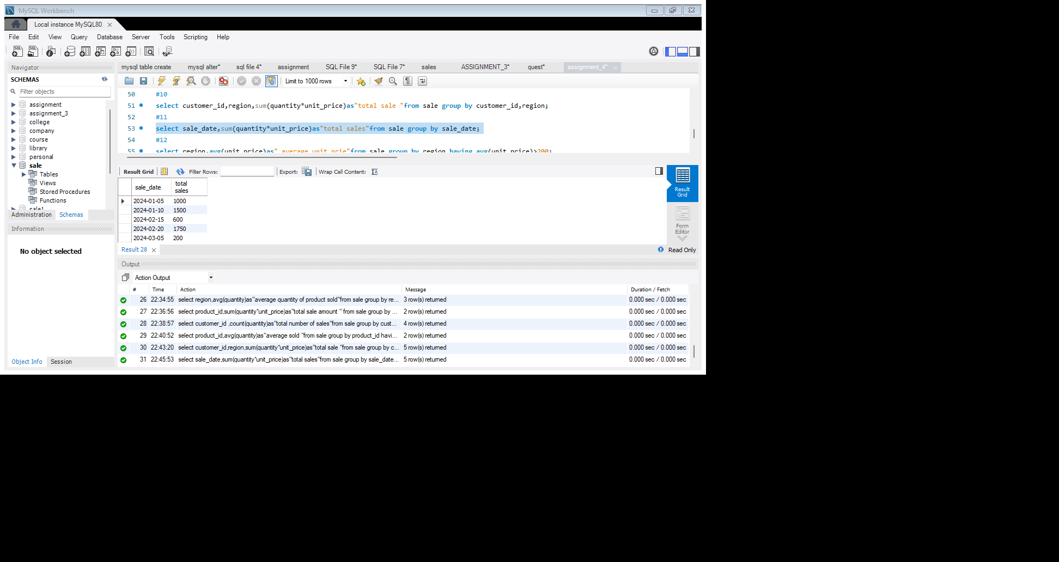

12. Find the regions where the average unit price is more than 200.

**Select region, avg(unit_price)as" average unit_price" from sale group by region having avg(unit_price)>200;**

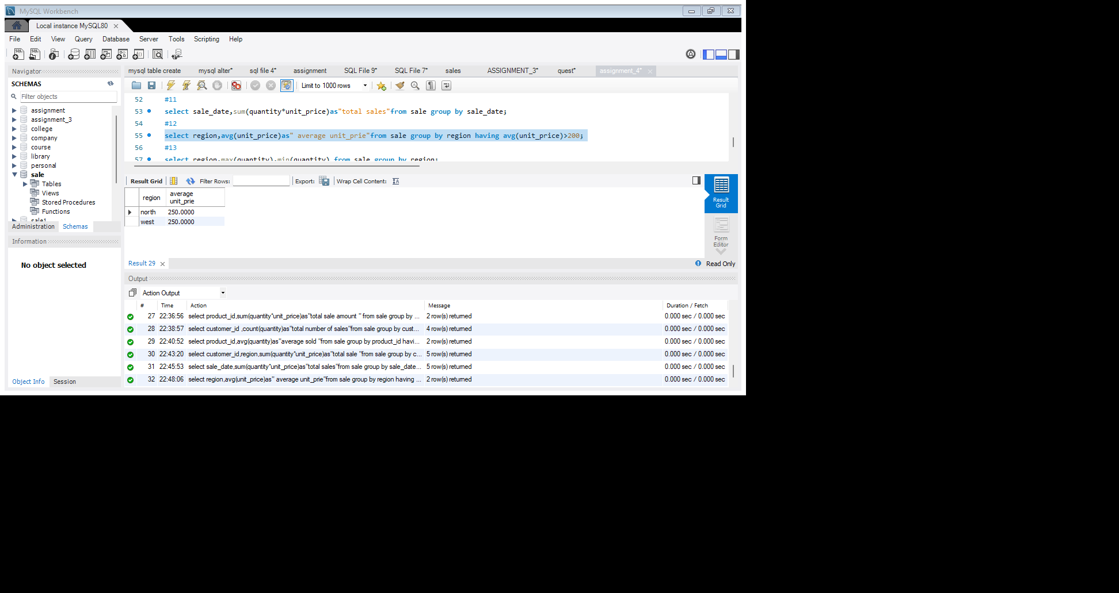

13. Write a query to get the maximum and minimum quantity sold per region.

**Select region,max(quantity),min(quantity) from sale group by region;**

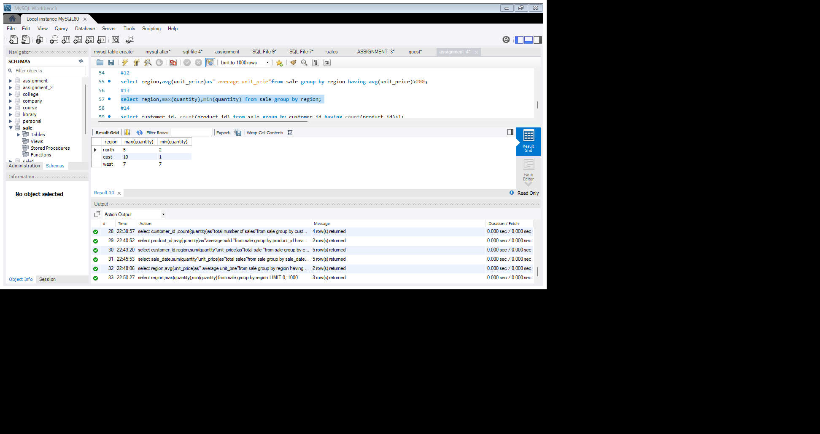

14. Find the customers who have made more than 2 purchases.

**Select customer_id, count(product_id) from sale group by customer_id having count(product_id)>1;**

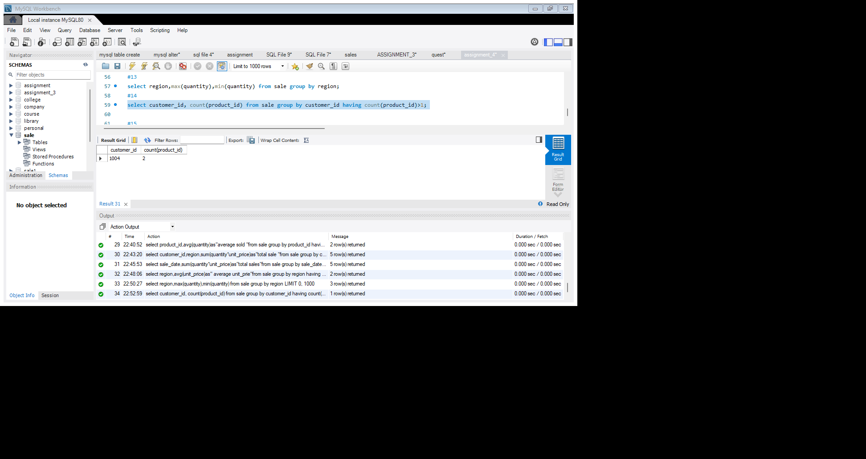

15. Write a query to find the total sales for each product and filter only those products where the total sales exceed 1500.

**Select product_id, sum(quantity*unit_price)as "total sale" from sale group by product_id having sum(quantity*unit_price)>1500;**

